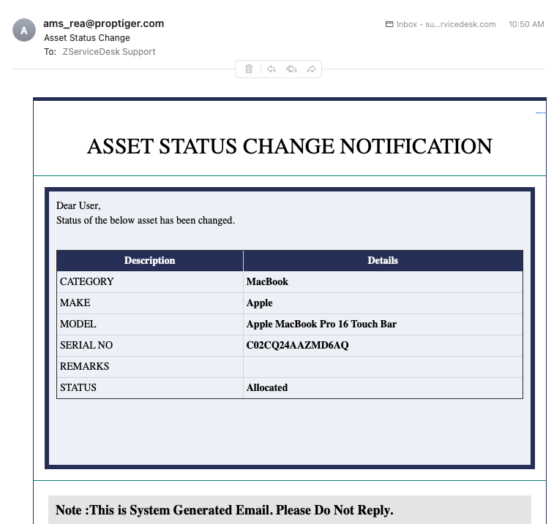

Add Asset Tag

Old Status – Need to add value

New Status – change only label name

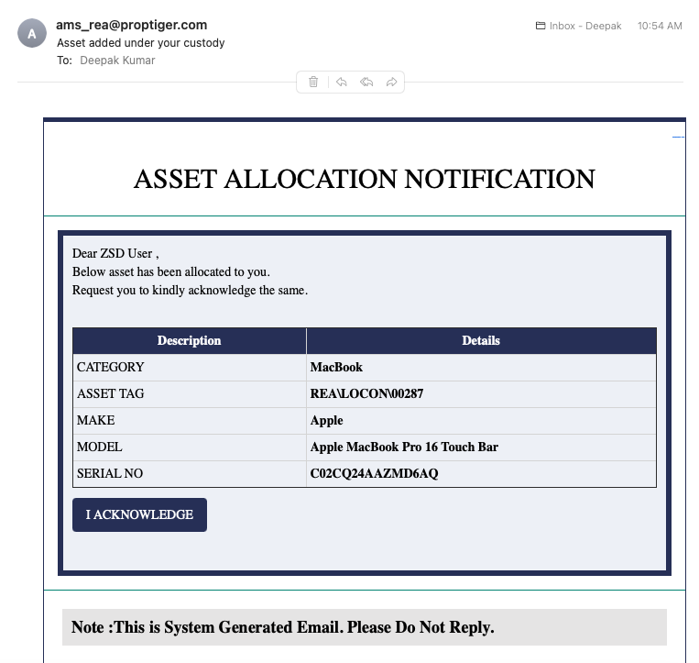

Add Employee ID in Subject Line

* Agent Last connected is missing in asset dashboard
* Rename Temp memory to Temp Files
* Add Logo with Barcode
* Send Gatepass over email
* Need to give option to remove mapping from system discovery table
* 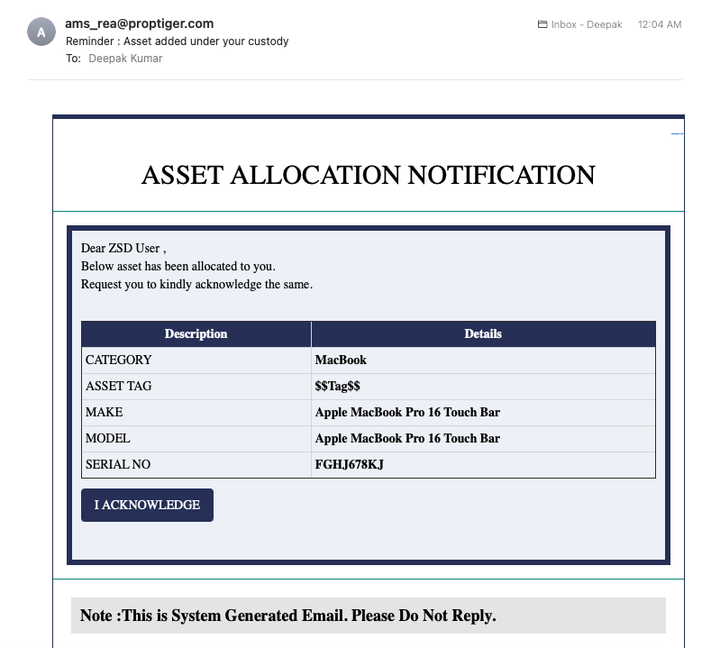
* Asset Tag is missing in reminder template

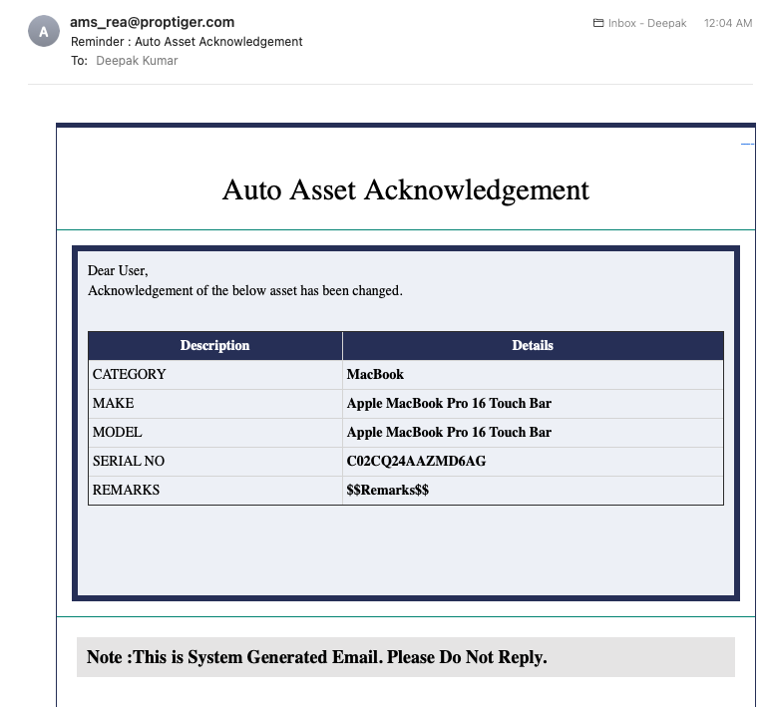

Chagnge subject line.

Remove Remark

Add Asset Tag

Add User Name

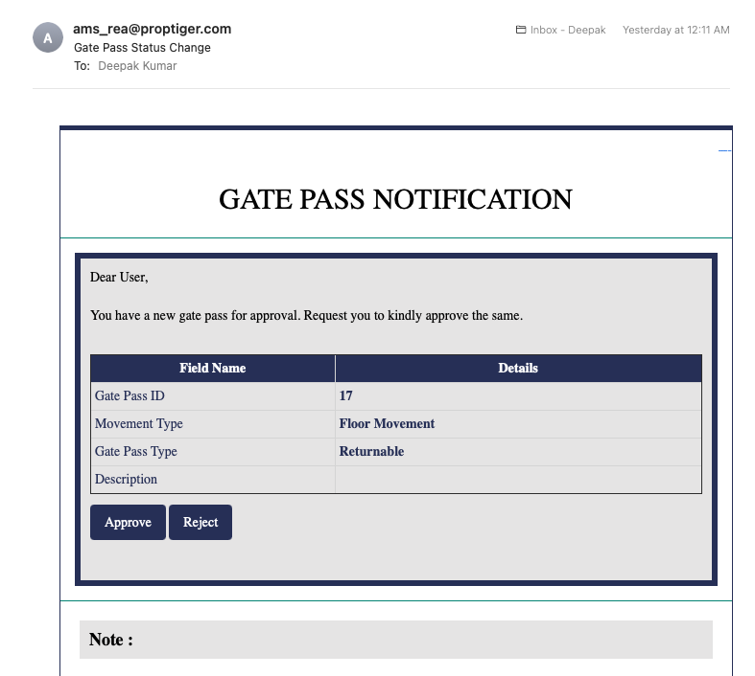

Change subject line to “New Gate Pass Created (Approval Required)

Show full Gate Pass ID

Change Description to Reason